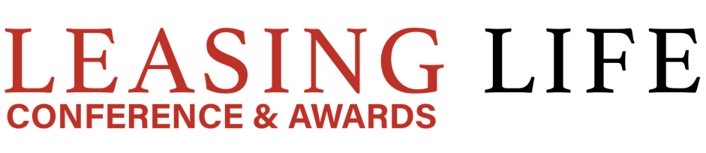

Four Seasons Hotel George V, Paris
15th November 2022

Leasing Life Awards 2022
https://arena-international.com/leasinglife/awards

Entry Form

PART A – must be received by 17.10.22
Company Details
Company Name
Company Address (including Postcode)
Contact Person
Contact Details
Submission Details
Item | Details
Tick Submission Award Categories | Distribution Channel Management Champion
 | Professional Services Provider
 | SME Champion
 | Vendor Finance Provider
 | European Lessor
 | Captive Lessor
 | Digital Innovation
 | Best ‘ESG/Sustainability’ Initiative of the Year (Social)
 | Best Circular Economy Model
 | Best Energy Transition financing program(s)
 | Young Professional of the Year
 | Industry Ambassador of the Year
 | Lifetime Achievement Award
PART B – must be received by 17.10.22
Award Snapshot
(Please describe in 1000 words or fewer why your programme or product should be nominated in this category. Please refer to the bullet points below the category when outlining your rationale.) Graphs and pictures can be copied into this document.

Website URL
Any other details you wish to share

